Title: AI Copilot Code Review using Large Language Models

Abstract
Software code review plays a vital role in improving software quality, security, and maintainability by identifying defects, coding standard violations, and potential vulnerabilities during software development. Traditional static analysis tools primarily detect rule-based issues but lack semantic understanding of source code, while Large Language Models (LLMs) generate intelligent review suggestions but may produce hallucinated or contextually inaccurate recommendations due to limited repository awareness. This project proposes an AI Copilot for Context-Aware Automated Code Review framework that integrates CodeLlama, CodeBERT, Static Analysis, and Retrieval-Augmented Generation (RAG) to generate accurate, explainable, and repository-aware code review suggestions. The overall structure and flow follow the style of the provided sample abstract.

The proposed system supports Python, Java, and JavaScript source code by performing language-specific static analysis using Pylint, PMD, and ESLint. Repository source files collected from CodeSearchNet and GitHub repositories are first processed through code chunking, after which CodeBERT generates semantic embeddings for each code chunk. The generated embeddings are stored in a FAISS vector database, enabling efficient retrieval of contextually similar code snippets. The retrieved repository context, together with the submitted source code and static analysis results, is incorporated into a structured prompt that is processed by CodeLlama 7B Instruct to generate intelligent review comments, suggested fixes, severity rankings, confidence scores, and explainable recommendations.

The proposed framework is evaluated using the CodeXGLUE benchmark dataset and real-world GitHub repositories to assess review quality and contextual relevance. System performance is measured using Precision, Recall, CodeBLEU, and qualitative evaluation of generated review suggestions. By combining semantic retrieval, repository context, static analysis, and Large Language Model reasoning, the proposed system aims to reduce manual code review effort while improving the accuracy, explainability, and reliability of automated code reviews. The framework also provides a scalable foundation for future integration with Integrated Development Environments (IDEs), CI/CD pipelines, and additional programming languages.

Datasets

dataset | links
CodeXGLUE | https://github.com/microsoft/CodeXGLUE.git
CodeSearchNet | https://github.com/github/CodeSearchNet.git
GitHub Public Repositories | https://github.com?utm_source=

Approach

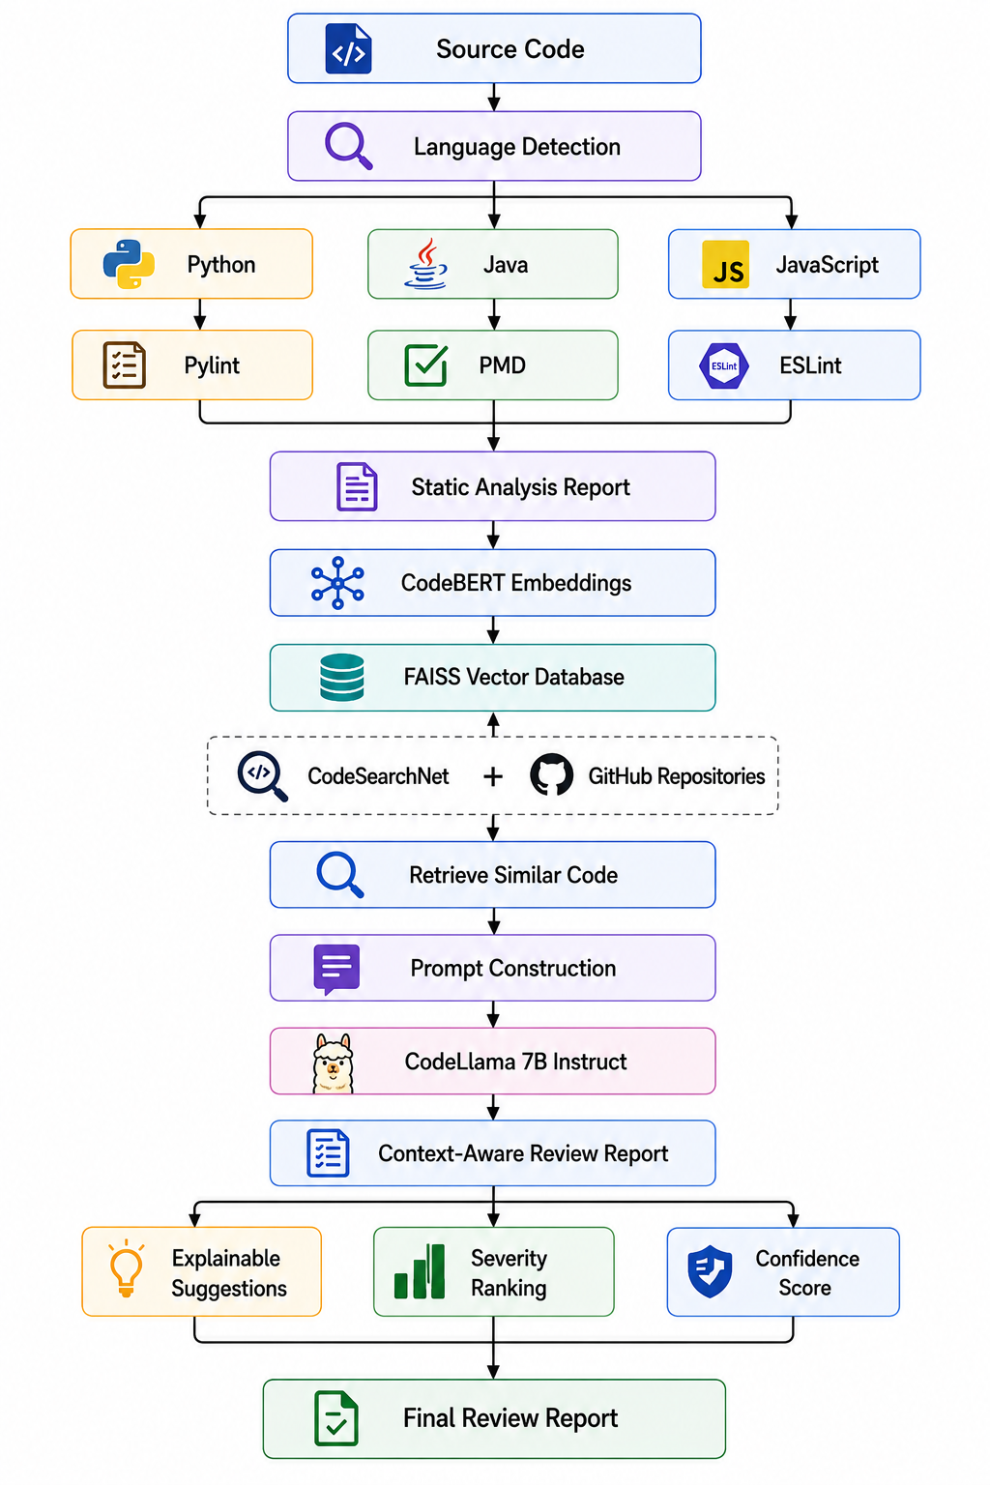
Project Group Members

S.No. | Roll.No. | Student Name
1 | 2420030099 | Bandi Srihitha
2 | 2420030093 | Emani Mahathi
3 | 2420030043 | Prathipati Pranathi

